Software Requirements Specification

For

Online Ticket Booking System
Version 1.0 approved
Prepared by Lohith Kumar Velkuri, Vynatheya Reddy Vuppunutula, Srikanth Reddy Ettem, Kiran Kumar Raju Ganga Raju
University of North Texas
10/2/19
Table of Contents
- Introduction
  - Purpose
  - Document Conventions
  - Intended Audience and Reading Suggestions
  - Project Scope
  - References
- Overall Description
  - Product Perspective
  - Product Features
  - User Classes and Characteristics
  - Operating Environment
  - Design and Implementation Constraints
  - User Documentation
- System Features
  - SF1: Login/Register page
  - SF2: Homepage
  - SF3: Event information page
  - SF4: Ticket information and selection
  - SF5: Payment gateway and order confirmation
- External Interface Requirements
  - User Interfaces
  - Hardware Interfaces
  - Software Interfaces
  - Communication Interfaces
- Other Non-functional Requirements
  - Performance Requirements
  - Safety Requirements
  - Security Requirements
  - Software Quality Attributes
- Development Phases
  - Phase 1
  - Phase 2
  - Phase 3
List of Figures
- Figure 2.1.1. Structure diagram
- Figure 2.2.1. Class diagram
- Figure 4.1.1. Login/Register page
- Figure 4.1.2. Homepage
- Figure 4.1.3. Event and venue information page
- Figure 4.1.4. Ticket ordering page

1. INTRODUCTION

Purpose

The main purpose of this project is to develop a web application for an Online Ticket Booking System. The web application would serve as a platform for the users to purchase tickets to various types of events held in several venues across multiple cities.

Document Conventions

The SRS document follows an easy to understand convention. The sections are displayed using Arial font in bold with a font size of 18 and the sub-sections are displayed using the same font in bold with a size of 14. Priorities of the requirements are stated in the SRS document based on each requirement. The document also consists of figures which are labeled and a list of figures is also provided in the SRS document.

Intended Audience and Reading Suggestions

The SRS document is intended for all kinds of readers including administrators, developers, testers, end users and business owners. The document consists of six sections: Introduction, Overall Description, System Features, External Interface Requirements, Other Non-functional Requirements and Other Requirements. Each section has multiple sub-sections which contain information regarding the software product, i.e., the web application that is being developed. The format of the SRS document is easy to understand and this can be used as a manual or a guide to learn about the software system. In order to read the most relevant parts for specific reader groups, the developers and testers may read the Sections 2, 3, 4, 5 and 6. The end users (customers), administrators and business owners may read Sections 1, 2 and 3. The administrators may additionally read Section 4 as well in order to obtain a better understanding of the system.

Project Scope

The software project, known as Online Ticket Booking System, involves a web application that enables the customers to browse various types of events, learn information about the events and the venues in which they are being organized, check the availability of tickets and buy tickets to events. The web application covers a wide range of events from multiple cities. The web application also includes different tiers of tickets for a single event. The prices for these different tiers may vary. An example of tiers would be Gold, Silver, Platinum, etc. The customers need to create an account and they can access all the features listed above in a simple and convenient manner. The role of the administrators would be to add events and information related to them, update the number of tickets allocated to an event and the availability of these tickets, confirm ticket purchases from customers. Additional responsibilities include updating any changes to the events such as date, time or seating capacity.

References

http://staruml.io/ : For creating UML diagrams
https://unt.instructure.com/courses/19039/files/3927613?module_item_id=1200644
https://guides.github.com/introduction/git-handbook/
https://stackoverflow.com/questions/16475979/what-is-the-difference-between-functional-and-non-functional-requirement
https://en.wikipedia.org/wiki/Software_requirements_specification

2. OVERALL DESCRIPTION

Product Perspective

The perspective of the software product is to provide the customers an application that is easy to use and navigate by providing ticket sales to a wide range of events spanning a wide range of categories. While most existing similar software products cater to events of a particular type, our product aims at covering events from many genres. The web application is expected to be a one-stop shop where customers with all interests can buy tickets to events of their interests.
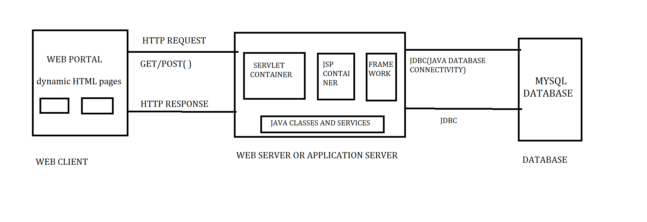Figure 2.1.1. Structure Diagram

Product Features

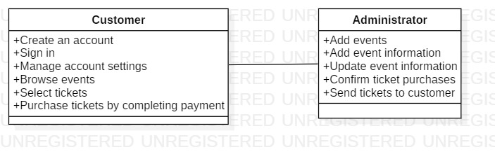Figure 2.2.1. Class Diagram

    - Create account
The user can register on the web application using his/her email. The user would need to provide a few details such as first name, last name, address, phone number and so forth. Moreover, the user can also provide his/her interests, favorite artists or performers, etc. so that the events that appear on their feed match their interests.
    - Sign in
Using the email that was used to create an account and password, the user can sign in to the application. The system (admin) verifies and validates the user’s credentials before allowing them to sign in to their account.
    - Manage account settings
The users can change any of the details provided above such as phone number, address and so forth. The users can also add, remove and update their interests later. Moreover, they can change their password if they want to.
    - Browse events
On the homepage, the user can view the current and upcoming events and browse through them. This tool will help in easily navigating to the particular events that the user is looking for.
    - View information
The users can view information about the events such as date and time, venue and so forth. This information will also be updated by the administrators in case there are any last-minute changes to the events by the organizers.
    - Buy tickets
The users can view the different types of tickets available for an event and the seating capacity of the venue and buy the amount of tickets they wish to depending on the availability of tickets. After completing the payment, the tickets will be sent to the customers at the address they provide.
    - Add and update events
The administrators add events to the web application after receiving information about the events from the organizers. The process of adding an event includes adding the event name, type, date and time, venue, seating capacity, number of tickets for sale, etc. If there are any changes to the events such as a change in venue or date and so forth, the administrator would update the information.
    - Confirm purchase
After the user completes the payment, the administrator confirms the purchase of the tickets. The tickets are then sent to the address of the customer.

User Classes and Characteristics

2.3.1 Customer
- The customer can visit the web application and search for ongoing events and upcoming events. The customer also has the flexibility to filter the events based on price range, event date, venue etc.
- If the customer wants to book a ticket and proceed further, he/she needs to create an account.
- If the customer already has an existing account, then he/she can login with their email and password and proceed further.
- If the customer is new and does not have an account, then they would need to provide a few details such as first name, last name, address, phone number, etc.
- Once the customer successfully logs in using their email and password, the users can view the different types of tickets available for an event and the seating capacity of the venue and buy the amount of tickets they wish to depending on the availability of tickets.
- Once the customer decides to book the tickets, they can view the seating availability and move further by selecting number of tickets to be purchased.
- Once the user selects the number of tickets, he/she can view the amount to be paid for the tickets.
- By clicking on pay option, they will be redirected to a secured payment gateway portal where they need to enter their credit or debit card details for payment or choose another available payment method as per their convenience.
- Once the payment is completed, the customer can view the tickets and can save them in their account so that they can even check the tickets offline in future.
- The customer receives a notification to his/her email regarding the payment receipt.
- Customer can provide their feedback for the event using ratings and review portals which will be visible to the other customers.

2.3.1 Administrator
- The administrator controls the web application. The administrator acts as arbitrator between the customer and the event organizers.
- Administrator is responsible for adding events into the website and providing insight about the event, etc.
- As we all know, events get postponed sometimes. In that case, the administrator is responsible for modifying the dates and venue details on the website so that the current viewing customers get to know about the modifications.
- Moreover, an email will be sent to the previous customers who had already booked the tickets so that they can be made aware of the changes.
- Whenever an event gets cancelled, admin will display it on the main page so that the customers are made aware of it.
- The admin reviews the issue raised by the customers in order to make possible changes to improve the web application.

Operating Environment

The product will be developed using Java and will be implemented in Windows XP or higher operating system. In the frontend, we will be using HTML, CSS, XML, jQuery and JavaScript. The database system that we are using for the system is MySQL and the server that we would use would be XAMPP. To connect the database to the server, we would use JDBC.

Design and Implementation Constraints

One of the constraints of this software product is that it is not adaptable to mobile devices currently. Another constraint in the design of the web application is that guest users cannot purchase tickets. In order to purchase tickets and avail the full functionality of the application, the users would have to register their accounts. Another constraint in the design of the product is that the users would be unable to save an event that they are interested in to their wish list so that they could revisit later. The product does not include a search bar option at present. The users would have to browse the list of events from the available catalog on their homepage using appropriate filters and criteria.

User Documentation

A user manual will be available as part of the project which would enable the users to understand and use the system easily. Additionally, the web application would also consist of an FAQ page (Frequently Asked Questions), where any questions and concerns about the product would be answered in a detailed manner. The user manual and FAQ page would also include information about how to handle any issues the users may face while using the interface.

SYSTEM FEATURES

SF1: Login/Register page

This is the page where new users create an account or existing users login to their accounts. This system feature has high priority. The database would classify the users as customers and set their privileges accordingly.

SF2: Homepage

In the homepage, the first thing to do would be to select a particular city to view the events being organized in that city. After that is done, then the user can view and browse the various events being organized in that city. This system feature has high priority.

SF3: Event information page

In this page, the customer can view the information about the event such as venue, artists, performers, etc. This system feature has medium priority.

SF4: Ticket information and selection

In the event page, the customer can see the types of tickets available, the number of tickets available, the seating capacity of the venue, ticket prices, etc. The customer can add his tickets in this page and the price of the purchase would reflect on the screen based on the number of tickets and the types of tickets being added to the cart. This system feature has high priority.

SF5: Payment gateway and order confirmation

This system feature has high priority. Our aim is to provide a secured payment gateway for the users to buy tickets. After buying the tickets, an order confirmation would be sent to the customers.

EXTERNAL INTERFACE REQUIREMENTS

User Interface

The login page acts as the index page of our website. Customers need to login to their account or register to the application using their email as username and a strong password when they click on the signup button.
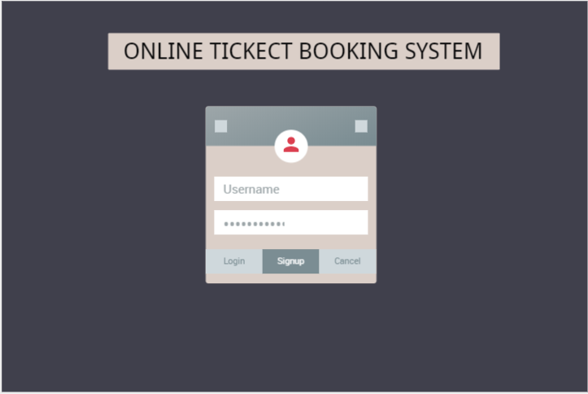
Figure 4.1.1. Login/Register page
Once a user logs in to his account, he/she can view the page below which shows the list of movies and events.
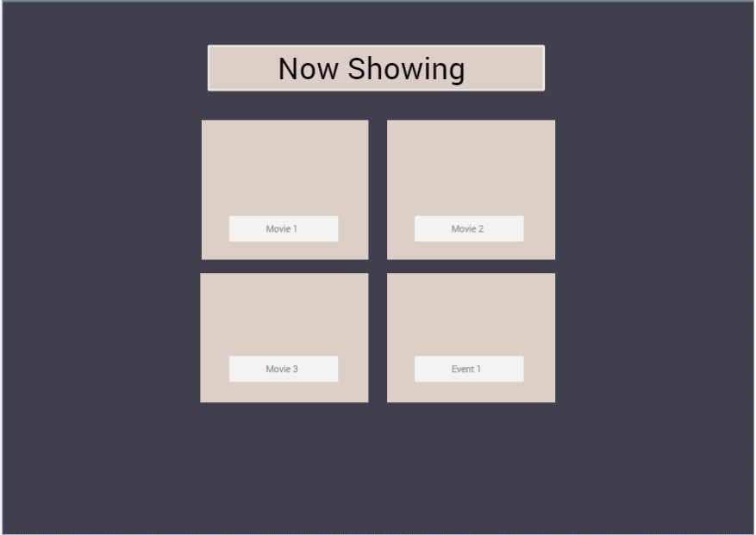
Figure 4.1.2. Homepage
After a user clicks on a movie or an event, he/she will be directed to the page below which shows their selection, the description and details of the movie or event and the venue details, out of which, they can a preferred venue.
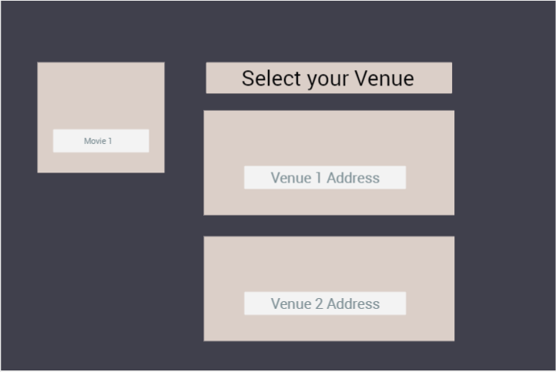
Figure 4.1.3. Event and venue information page
Then, the user will see ticket information and order form page, where we publish the details about the event and venue so that the user knows exactly the event for which they are purchasing tickets. The user can purchase multiple tickets and based on their selection, the total price is generated including the applicable taxes. The user can either continue to pay or reset the selection. If they continue to pay, they get confirmation details in the next page.
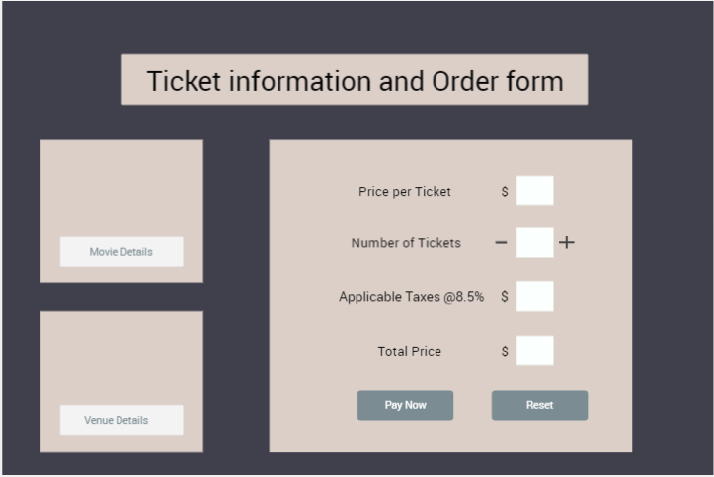
Figure 4.1.4. Ticket ordering page

Hardware Interfaces

The Online Ticket Booking System can run on any device such as a Laptop/Desktop computer system which has an internet connection with speeds greater than 1Mbps and supports a web browser.

Software Interfaces

• Java (Version 1.8): This technology is used for backend business logic development.
• MySQL(version-5.0.12): MySQL is the database engine used for the application.
• HTML: It is used to build the front end of the web application.
• CSS: It is used to style the web pages.
• Bootstrap (Version 4): This is used for responsiveness of the web application. This framework provides an excellent platform to split the page into grids depending on the device size.
• IDE: Eclipse (version- Oxygen)
• Web Browser: Any web browser (Chrome/IE/Safari/Edge/Opera etc.) released post 2006.

Communication Interfaces

We are using localhost server to deploy our project. Customers submit the electronic forms for communication. This application is supported on all web browsers.

OTHER NON-FUNCTIONAL REQUIREMENTS

Performance Requirements

Performance plays a major role in usability of the application which we cannot estimate while developing the application. We have opted a process which would allow us to estimate if any change that we made to our existing system is causing severe performance issues.
We need to identify if there are any significant modifications to the architecture of the current application which would affect the performance of the system. Response time of requests need to be calculated frequently before and after a new change is implemented. Huge data would also cause depreciation in the performance. Workload is another factor which might affect the performance. The platform in which the application is running would affect the performance as well.
For our Login page, we expect the user to get logged in to the system within 3 seconds and for the homepage to be loaded. We expect if the user credentials are correct, the user needs to be directed to homepage in 4 seconds. For the other functions, like navigation between events, we expect any time less than 2 seconds would work. For the payment gateway, we cannot handle this as we will be using a third-party application for the payment processing. Once the payment is done, we expect the ticket to be generated within 5 seconds. Performance need to be optimized after the development is completed (at least the proof of concept would give a brief performance overview).
System design would be a deciding factor for the performance of the complete application and we will need to take care of the design aspect and the time constraint of every operation even while developing code and try to achieve required functionality in minimum time complexity possible.

Safety Requirements

Users accessing our application will be registered first before proceeding to booking a ticket. If there is any invalid or anonymous booking on their account, the user will be notified by email which he/she can report in case of any misuse of the account. The user is responsible for his/her account credentials and tracking of the account usage will help in resolve any safety issues.
We will try to the best of our knowledge and the information that we received through sources related to keep the event information authentic. If there is any cancelation in the event organization or any delay in the event , user will be informed through email about the event status. We advise the users to please check emails frequently for any information that we provide. Please be aware that there might be false information provided from the host of the event which might affect your experience.

Security Requirements

Users will be accessing our web application using their credentials like email and password. We will not be disclosing the user information as we will be encrypting the password before storing it in our database. Even the database administrator will not be able to decrypt the user information. We assure the users that the information that is provided to us will not be disclosed to outsiders. Data encryption and user authentication are the two main security measures that we are considering in maintaining the security of the application.

Software Quality Attributes

Reusability: This application will have functions which are modular and independent whenever possible with a few input parameters. This will allow us to reuse the code in developing additional modules in our own application and also while developing similar applications.

Availability: This application will be available 24*7 to the end users and will be accessible from any place with internet connected to their devices.

Maintainability: Developing a web application is a one-time task but to let the users stay with our application or to attract new users, we need to maintain the application and keep it up to date with latest technologies for the application to be attractive and user-friendly. In our application, as we are developing the code in multiple layers, we will be easily able to manage any change/update in the requirement and integrate new technologies according to the need of the industry.

Secured Payment Gateway: As our application needs users to buy tickets online for the events/movies, we need to take care of the payment gateway as we do not want fraud transactions or slow processing of the transaction. We will be using Paypal Sandbox (still under discussion) to avoid these issues as it is a global payment gateway and would be reliable.

Correctness: We will be providing the users with fully authentic proofed data as our application mainly relies on trust. User believes on our data and plans his day to attend movie/event by purchasing tickets from our application and even if we have a minute mistake in our data, we will loose customers trust. So we will be providing the users with proofed data.

Tracing(Logging): We will implement information logging during the flow of user through out the application flow. In any case of exception or transaction failure or any other issue reported by the user, we will have evidence of the logged in users and their information of what the logged in user did to raise the exception. It will help in identifying issues and will be reported for maintenance for them to be resolved.

DEVELOPMENT PHASES
This application will be delivered in three development phases. Crucial functionalities will be delivered by phase 2 and the last phase will primarily focus on developing and optimizing the developed application. Before this phases, we have gathered the requirements and other necessary resources that are required for the development

Phase 1 (10-1-19 to 10-20-19)
For the phase 1 development, below are the identified system features which will be delivered.
System Feature 1: Login/Register page
System Feature 2: Home page

Phase 2 (10-21-19 to 11-04-19)
For the phase 2 development, below are the identified system features which will be delivered.
System Feature 3: Event Information page
System Feature 4: Ticket information and selection

Phase 3 (11-05-19 to 11-18-19)
For the phase 3 development, below are the identified system features which will be delivered. Primarily, Testing, performance improvements and UI improvements will be focused on this phase.
System Feature 5: Payment Gateway and Order confirmation

